# MongoDB database installation

## Requirements

* Unix system to run the scripts that establish the database(Linux,MacOS,Windows Subsystem for Linux (WSL) in Windows systems)
* Software packages:
  1. Docker engine
  2. Ansible
  3. Python3-pip
  4. Ansible-Runner
  5. Pymongo
  6. BeautifulSoup4

## Instructions

The user can create a MongoDB database locally with content from Ansible Galaxy. To accomplish this, the user downloads the files required to create the database within a docker container named 'mongodbcontainer.' The user runs the script 'createMongoDB.sh,' which starts the entire process.

After the execution of the script, the following menu appears:

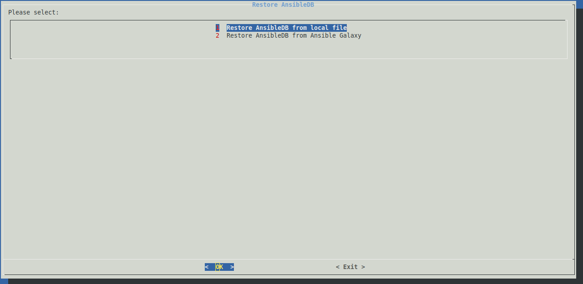

The first option creates a MongoDB database with content from a local backup stored in the downloaded folder. This is the faster of the two options, and it creates the MongoDB database without taking into account changes and updates made in Ansible content from Ansible Galaxy after the local backup is created.

The second option also creates the MongoDB database, but the content is retrieved directly from Ansible Galaxy via the Internet. As a result, the process of creating the database is quite different and takes several hours. Following the selection of the second option, the following screen appears:

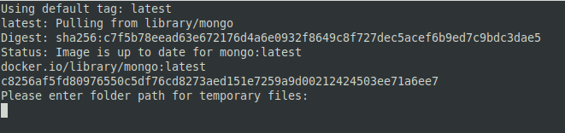

The user must enter an absolute path of the local file system where Ansible Galaxy data will be temporarily stored. This data contains the information required to create the database and will be deleted once the script has completed its execution. Furthermore, the input must follow the following pattern: ‘/example/username/folder/’. Then, the user must enter the default path where the ansible collection is stored. This path, for example, usually takes the following form: ‘/home/username/.ansible/collections/’.

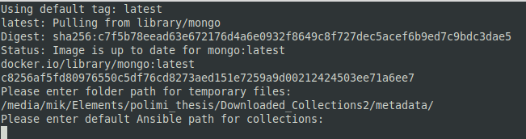

In both cases the database runs on port 27017.